Running Logistic Regression

Software Prerequisites:

1. MATLAB (preferably a 2014 or 2015 version) with DSP system toolbox
2. All Scarlett 18i8 drivers installed, including ASIO diver
3. Hardware
   1. Connect Focusrite Scarlett 18i8 to the computer
   2. Place each microphone in a stand and place all microphones stands roughly 45 feet away from the computer and 18i8. See (3) in the comments section for more info.
   3. Use XLR cables to connect microphones to the 18i8, as indicated by figure below
   4. Press the two “48V” buttons on the 18i8. The buttons should light up red.
   5. Set the gain knobs all to the same level for each channel. See (1) in comments section.

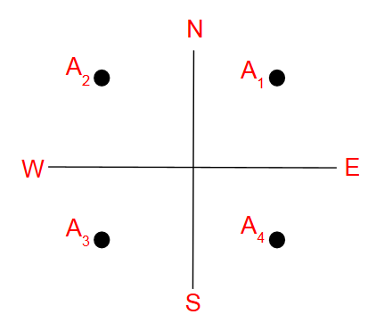

Figure 1: Channel setup

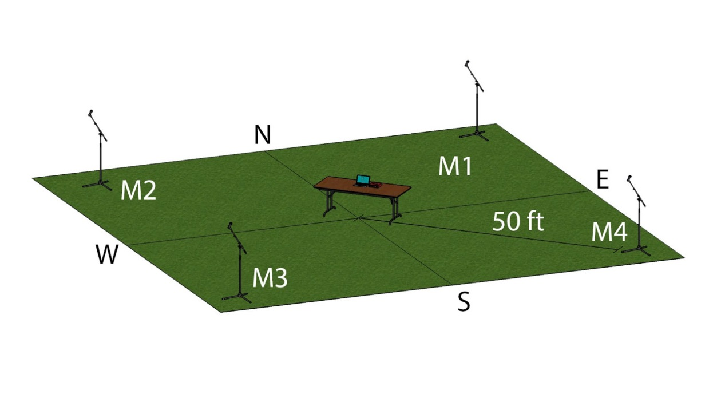

Figure 2: Physical setup of the system

1. Prepare MATLAB
   1. Open MATLAB (we used 2015b for development).
   2. Add all folders and files that were provided in the drone detection software package to the active path.
   3. Under the “Home” tab, click “Preferences”. In “DSP System Toolbox” settings, select “ASIO” as the audio hardware API.

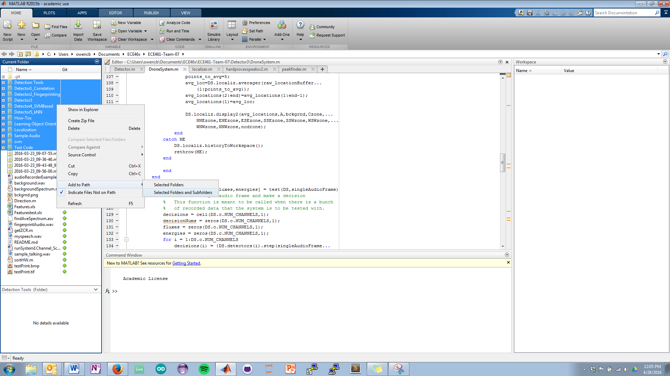

Figure 3: Adding folders to the path

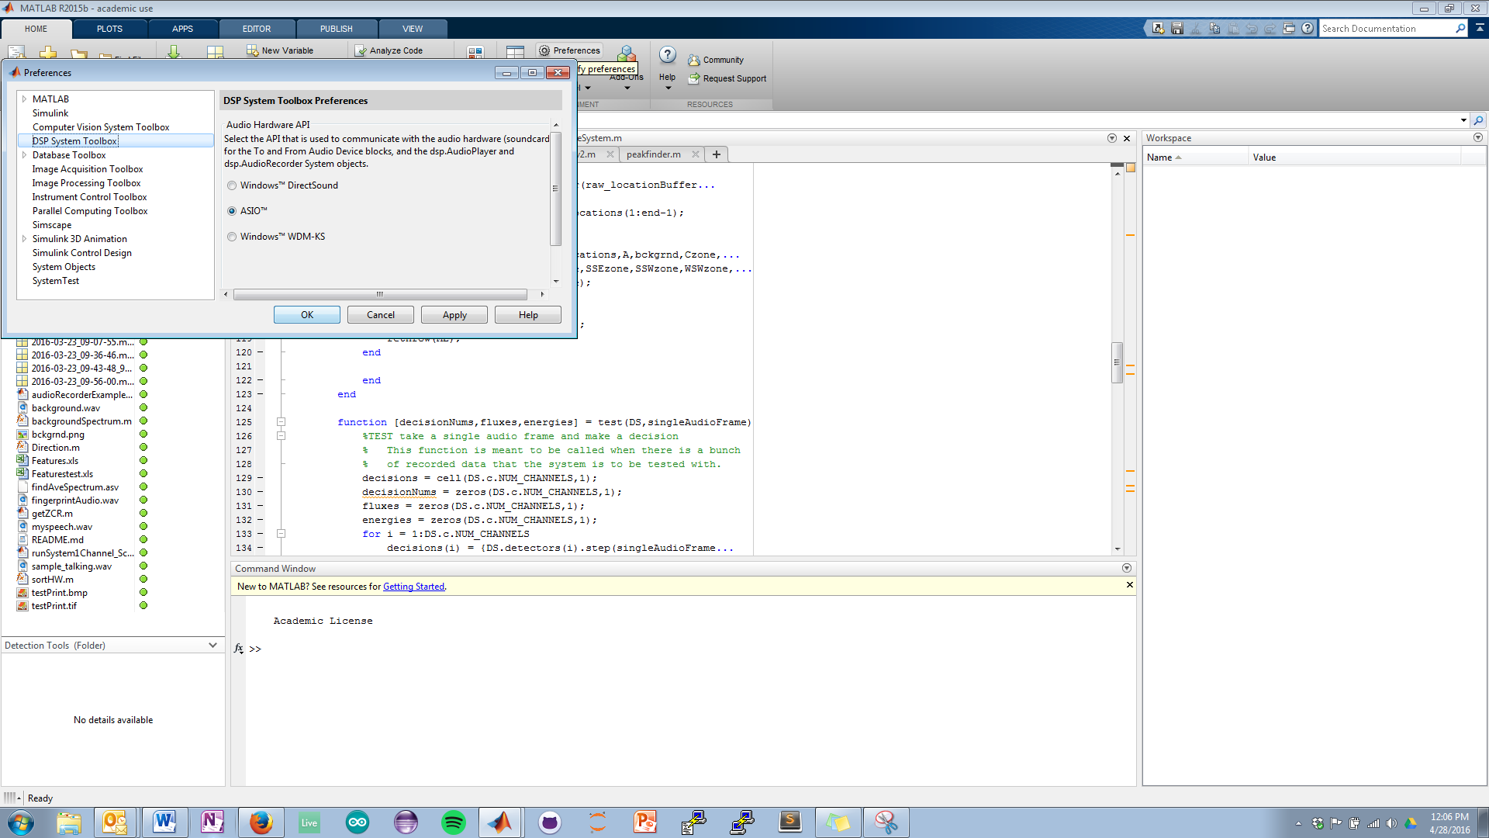

Figure 4: Switching to ASIO drivers

1. Run the system
   1. In the MATLAB command prompt, type logisticRegression4Channel and press enter.
   2. Navigate to the directory where the signal profiles are located. Use Ctrl+Click to select multiple signal profiles. Select as many as you need.
   3. Select whether you chose only one signal profile, multiple profiles, or if you want to cancel setup.
   4. Type in the name of the .mat data file that you want and click OK.
   5. Press the appropriate button to confirm or re-enter the file name.
   6. Select the appropriate cutoff probability and model building fraction. Click OK.

Comments:

1. Gain knobs
   1. The default level is maximum. All knobs point down and to the right.
   2. On days where weather causes detection issues, the knobs can be turned down to compensate at the cost of reduced range.
   3. Be sure that the knobs are all at the same level; the detection system assumes this.
2. ASIO4ALL
   1. A free and trusted ASIO driver can be found here: <http://www.asio4all.com/>
3. The system depicted in figure 2 shows the microphones 50 feet away from the center of the system. Since the cables are exactly 50 feet and some slack is needed, the stands will be about 42-45 feet away.